
YISHUN INNOVA JUNIOR COLLEGE
JC 2 PRELIMINARY EXAMINATION
Higher 2

CANDIDATE
NAME

CG |  |  |  |  |  |  | INDEX NO

GEOGRAPHY  Paper 1  INSERT | 9173/01 (REVISED)  27th August 2024  3 hours

READ THESE INSTRUCTIONS FIRST
This Insert contains all the Resources referred to in the questions.

INSERT

This document consists of 8 printed pages.

Resource 1 for Question 1

E-waste collection rate in the world in 2019
(in percentage)

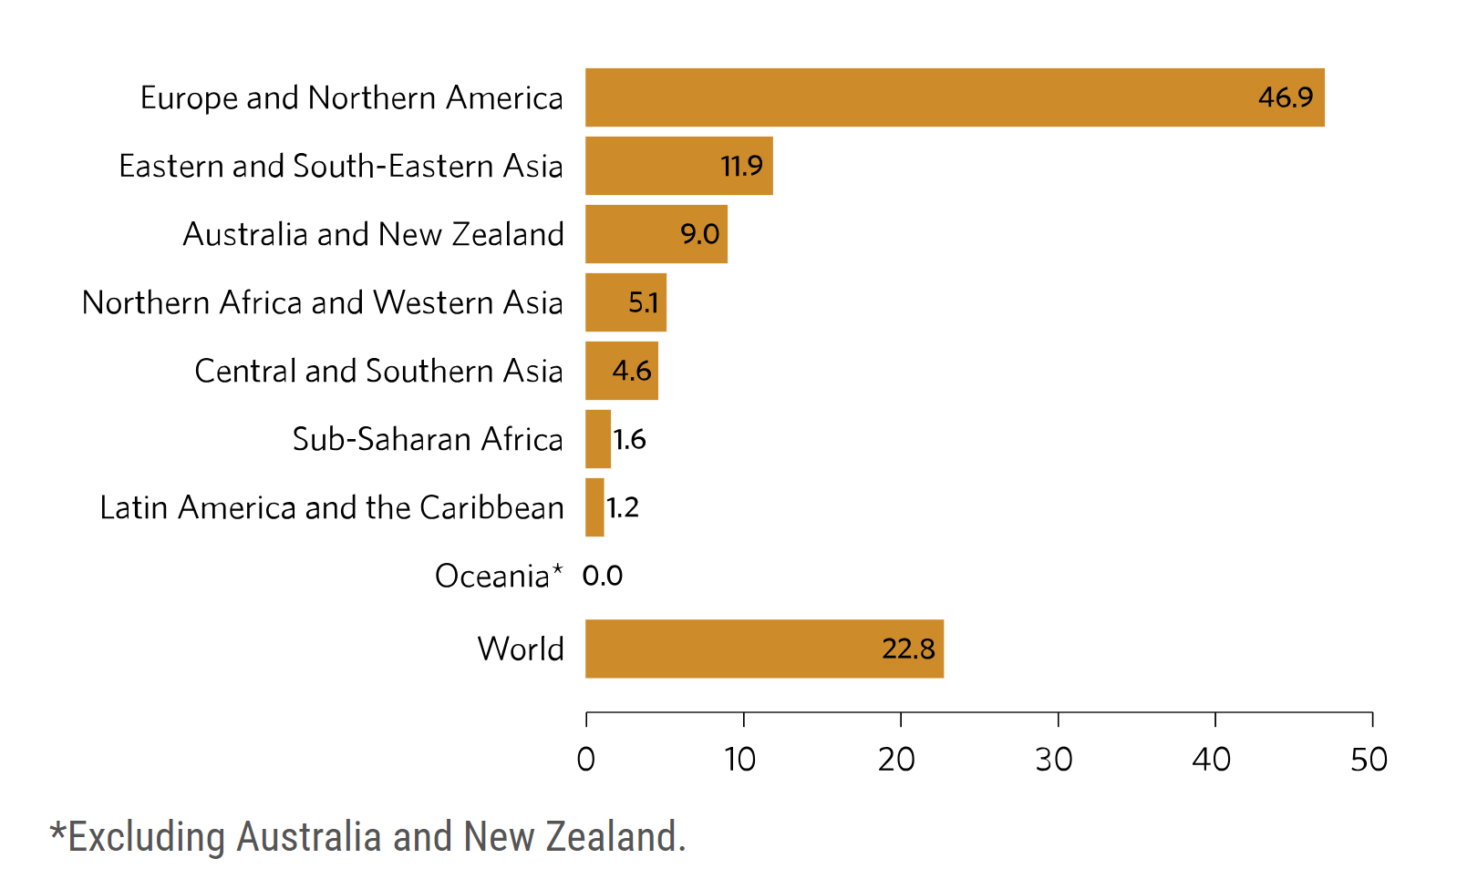

Resource 2 for Question 1

Reliance on Fossil Fuels, 2022

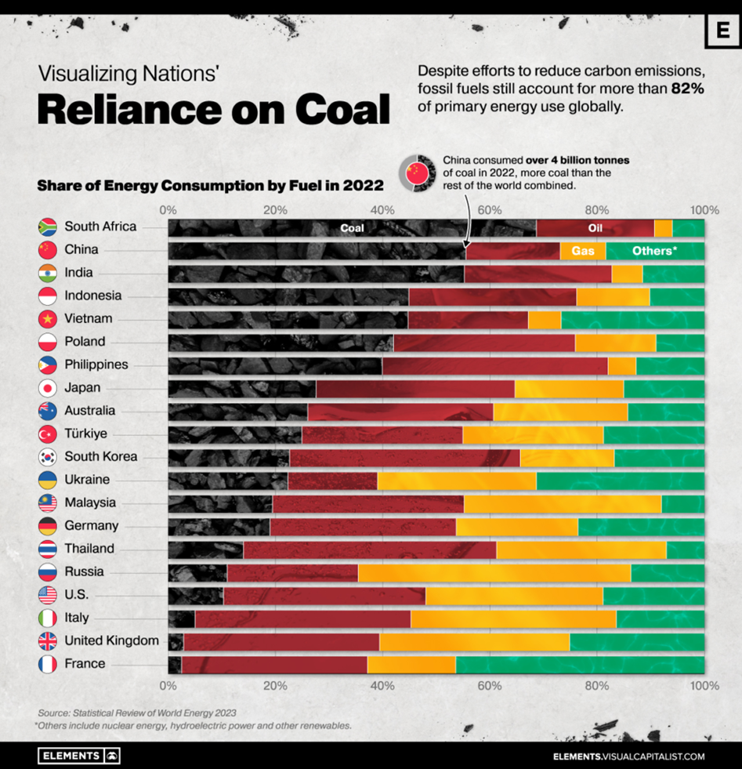

Resource 3 for Question 1

Renewable Energy in the World

A newly released report from the International Renewable Energy Agency has found Renewable energy capacity around the world has more than doubled in the 10 years between 2013 and 2022.

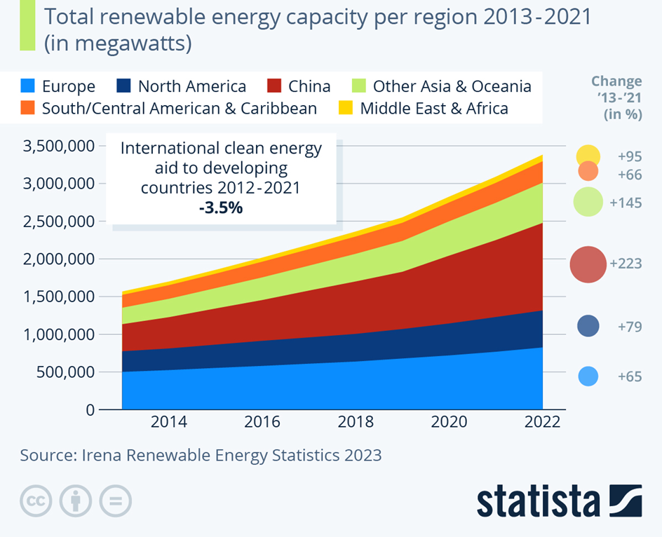

Resource 4 for Question 1

Renewable energy usage in the world in 2020

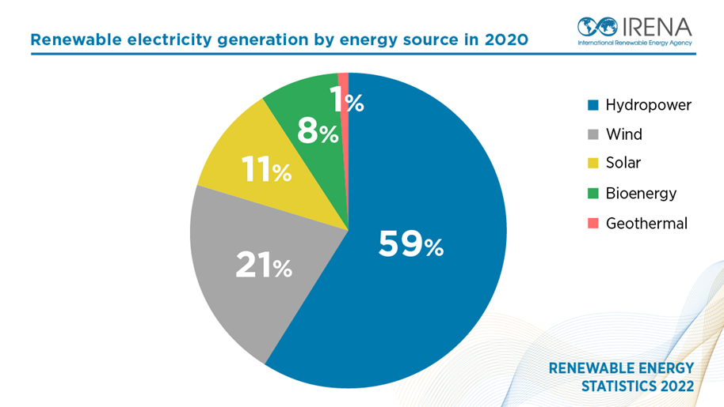

Resource 5 for Question 2
Climate graph of Dhaka, Bangladesh
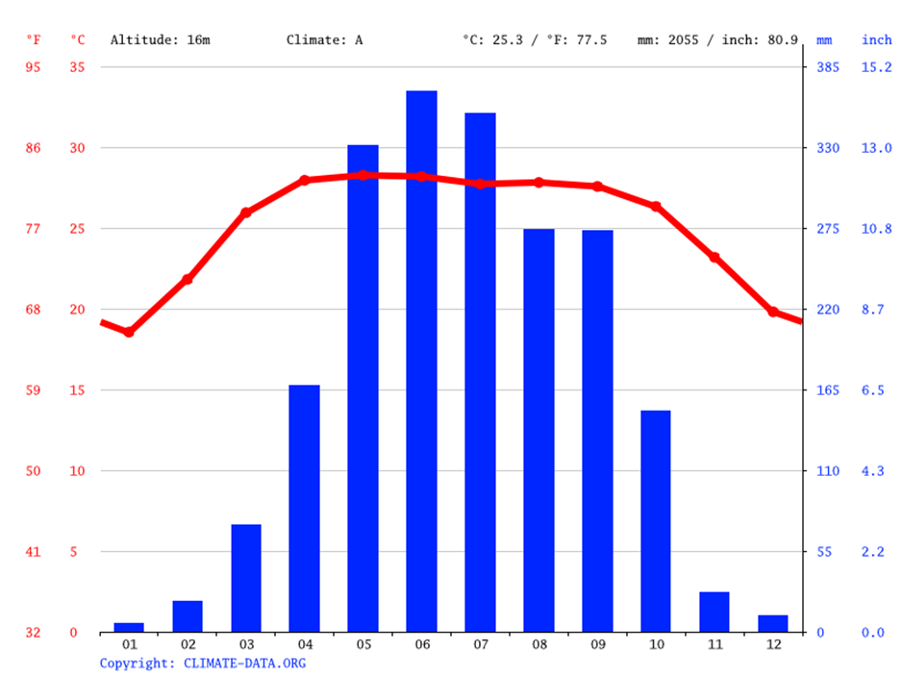

Resource 6 for Question 2

Photograph of the Brahmaputra River at the Middle Course

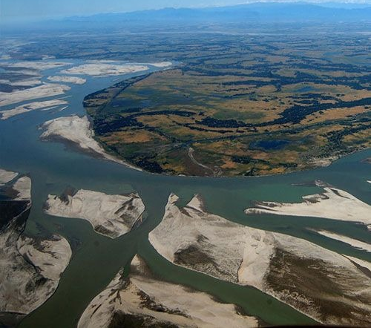

Resource 7A for Question 2

Photograph of the Brahmaputra River at Dhaka

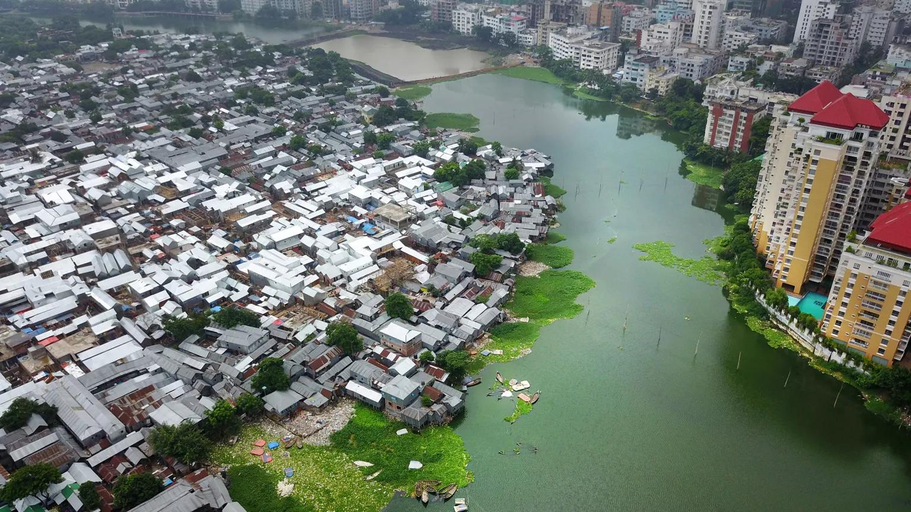

Resource 7B for Question 2
River flood at Dhaka, Bangladesh
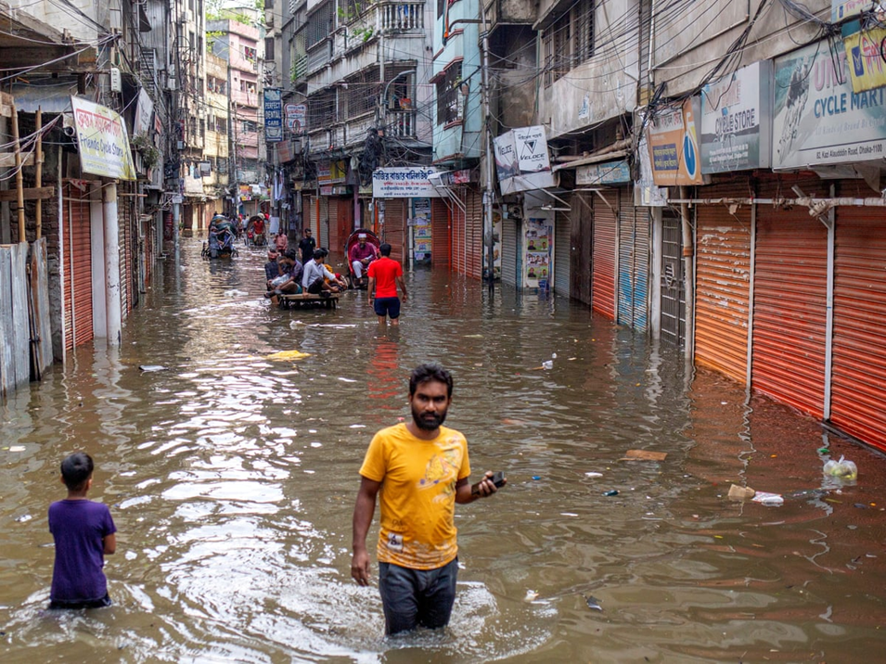

Resource 8 for Question 2

Map showing the Ganges Brahmaputra River in Bangladesh

The Ganges Brahmaputra (GB) delta is one of the world's largest deltas. It is currently experiencing high rates of relative sea-level rise of about 5 mm/year.
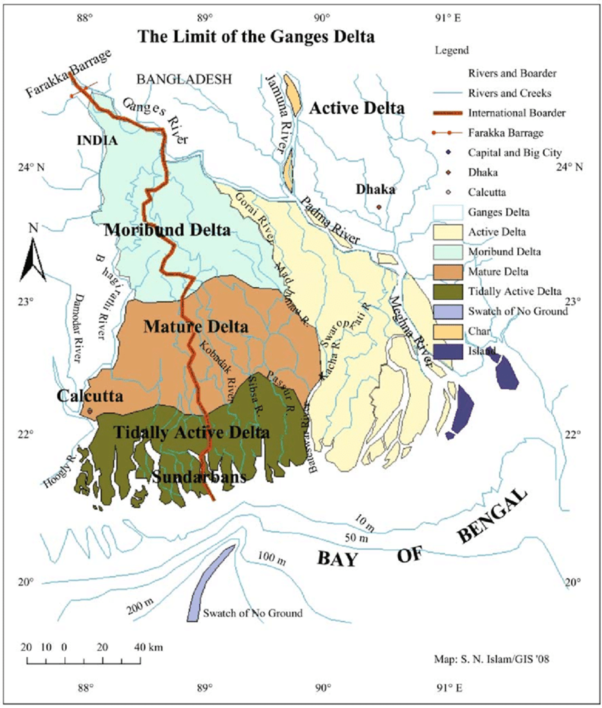

*In a tidally active delta, new distributaries are formed during times when
there is a lot of water around – such as floods or storm surges

Blank
Page

